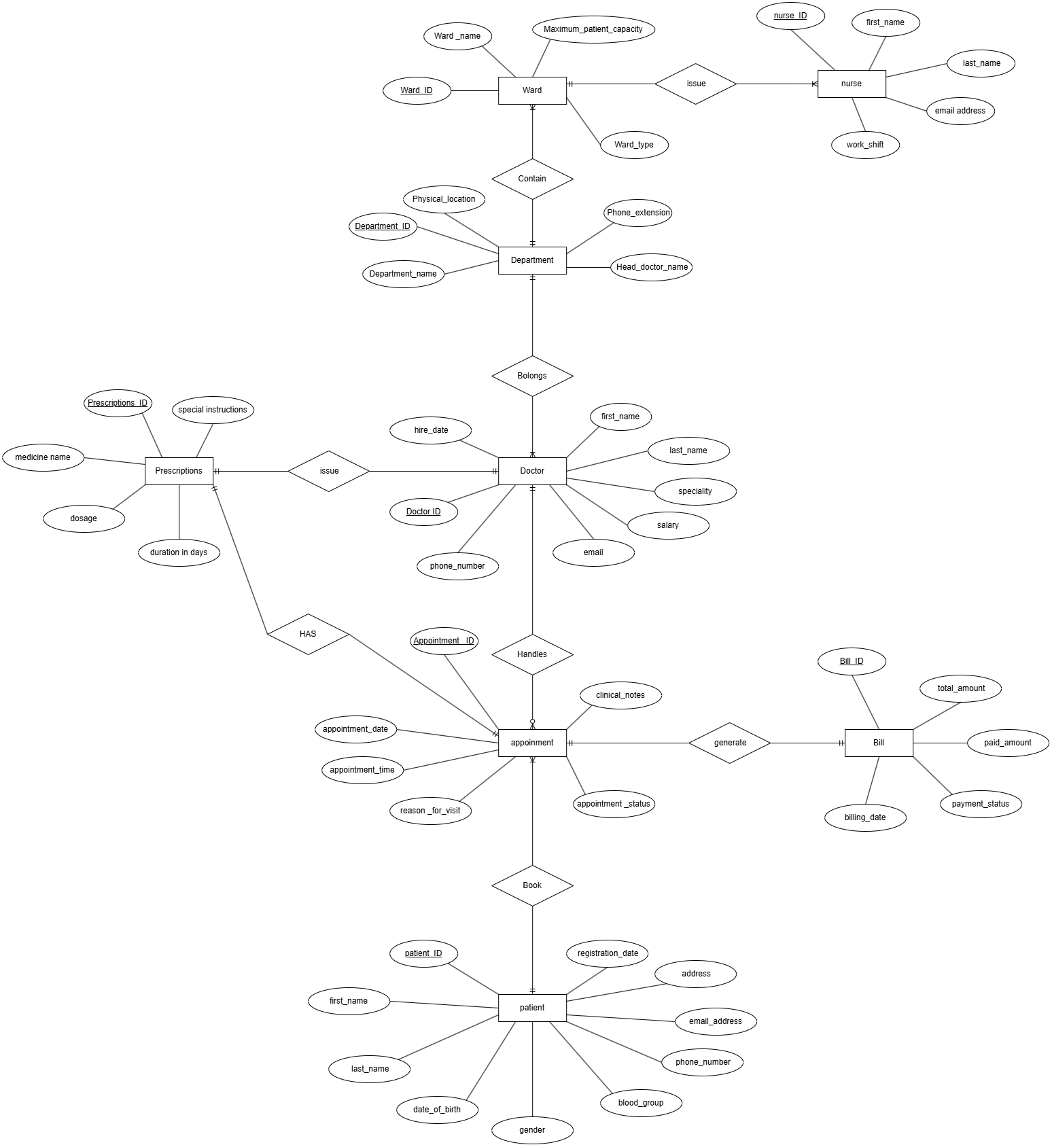
Q1.
Q2.
mysql> CREATE DATABASE citymed_hms;
mysql> USE citymed_hms;

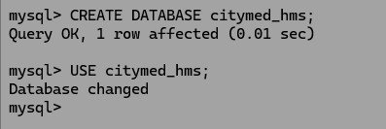

Q3.
CREATE TABLE departments(
-> dept_id INT AUTO_INCREMENT PRIMARY KEY,
-> dept_name VARCHAR(100) NOT NULL UNIQUE,
-> location VARCHAR(150) NOT NULL,
-> phone_ext CHAR(10) NOT NULL,
-> head_doctor VARCHAR(100) NULL
-> );

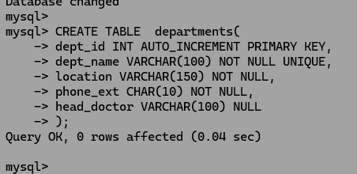
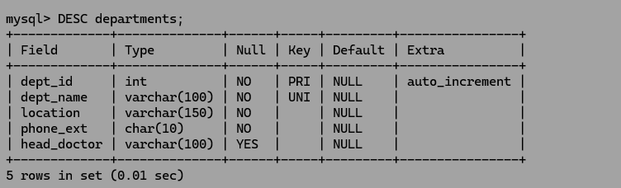

Q4.
CREATE TABLE wards(
-> ward_id INT AUTO_INCREMENT PRIMARY KEY,
-> ward_name VARCHAR(100) NOT NULL,
-> dept_id INT NOT NULL,
-> capacity INT CHECK (capacity BETWEEN 1 AND 100),
-> ward_type VARCHAR(20),
-> FOREIGN KEY (dept_id) REFERENCES departments(dept_id)
-> );

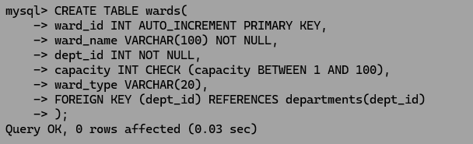

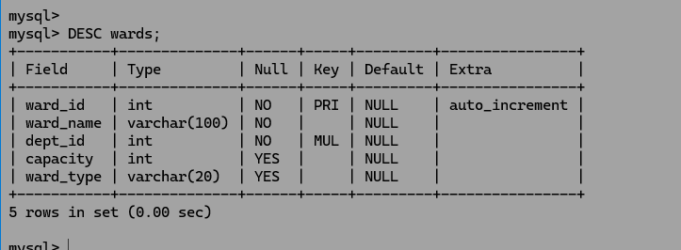

Q5.

CREATE TABLE doctors(
-> doctor_id INT AUTO_INCREMENT PRIMARY KEY,
-> first_name VARCHAR(50) NOT NULL,
-> last_name VARCHAR(50) NOT NULL,
-> speciality VARCHAR(100) NOT NULL,
-> dept_id INT NOT NULL,
-> email VARCHAR(100) UNIQUE,
-> phone VARCHAR(20) NOT NULL,
-> hire_date DATE,
-> salary DECIMAL(10, 2),
-> FOREIGN KEY (dept_id) REFERENCES departments(dept_id)
-> );

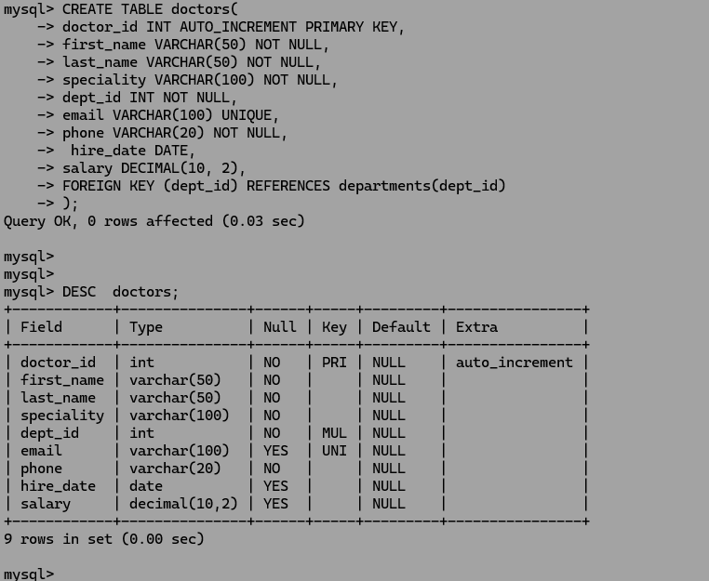

Q6.
CREATE TABLE nurses(
-> nurse_id INT AUTO_INCREMENT PRIMARY KEY,
-> first_name VARCHAR(50) NOT NULL,
-> last_name VARCHAR(50) NOT NULL,
-> ward_id INT NOT NULL,
-> shift VARCHAR(20),
-> email VARCHAR(100) UNIQUE,
-> FOREIGN KEY (ward_id) REFERENCES wards(ward_id)
-> );

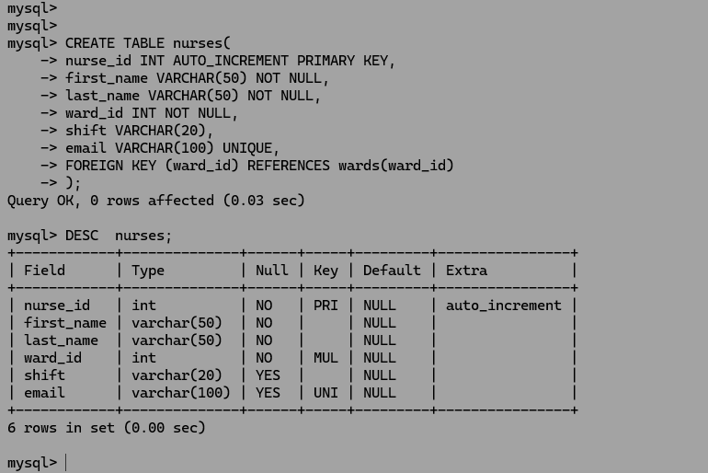

Q7.

CREATE TABLE patients(
-> patient_id INT AUTO_INCREMENT PRIMARY KEY,
-> first_name VARCHAR(50) NOT NULL,
-> last_name VARCHAR(50) NOT NULL,
-> dob DATE,
-> gender VARCHAR(10),
-> blood_group VARCHAR(5) NULL,
-> phone VARCHAR(20) NOT NULL,
-> email VARCHAR(100) NULL,
-> address TEXT NULL,
-> registered_on DATE DEFAULT (CURRENT_DATE)
-> );

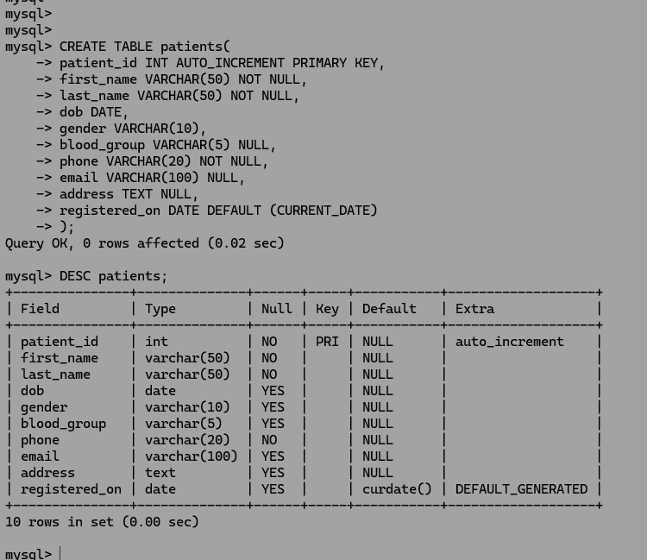

Q8.
CREATE TABLE appointments(
-> appointment_id INT AUTO_INCREMENT PRIMARY KEY,
-> patient_id INT NOT NULL,
-> doctor_id INT NOT NULL,
-> appt_date DATE,
-> appt_time TIME,
-> reason VARCHAR(255),
-> status VARCHAR(20),
-> notes TEXT NULL,
-> FOREIGN KEY (patient_id) REFERENCES patients(patient_id),
-> FOREIGN KEY (doctor_id) REFERENCES doctors(doctor_id)
-> );

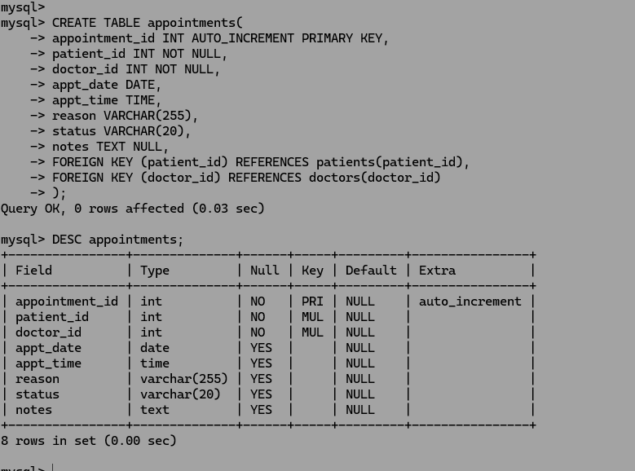

Q9.

CREATE TABLE prescriptions(
-> prescription_id INT AUTO_INCREMENT PRIMARY KEY,
-> appointment_id INT NOT NULL,
-> medicine_name VARCHAR(150),
-> dosage VARCHAR(50) NOT NULL,
-> duration_days INT,
-> instructions TEXT NULL,
-> issued_date DATE DEFAULT (CURRENT_DATE),
-> FOREIGN KEY (appointment_id) REFERENCES appointments(appointment_id) ON DELETE CASCADE ON UPDATE CASCADE,
-> UNIQUE (appointment_id, medicine_name)
-> );

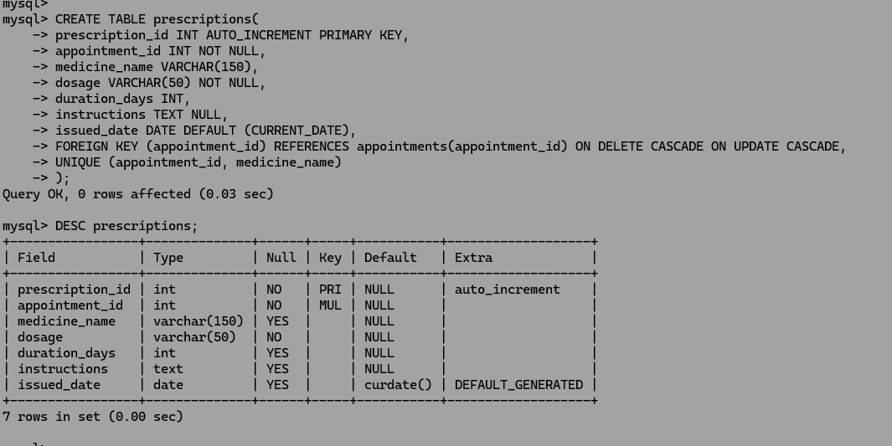

Q10.
CREATE TABLE bills (
-> bill_id INT AUTO_INCREMENT PRIMARY KEY,
-> appointment_id INT UNIQUE,
-> total_amount DECIMAL(10, 2) CHECK (total_amount > 0),
-> paid_amount DECIMAL(10, 2) DEFAULT 0.00,
-> payment_status VARCHAR(20),
-> billing_date DATE DEFAULT (CURRENT_DATE),
-> FOREIGN KEY (appointment_id) REFERENCES appointments(appointment_id),
-> CONSTRAINT chk_paid_amount CHECK (paid_amount <= total_amount)
-> );

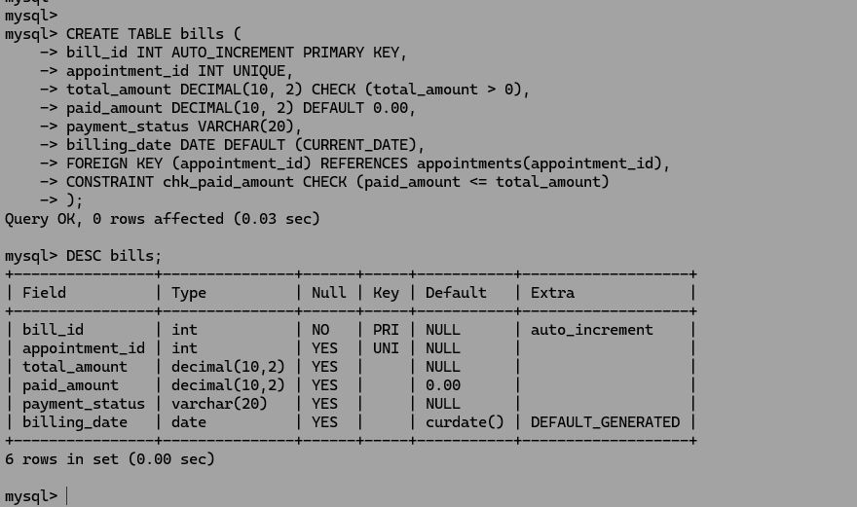

Q11.
ALTER TABLE patients ADD emergency_contact VARCHAR(20) NULL AFTER address;

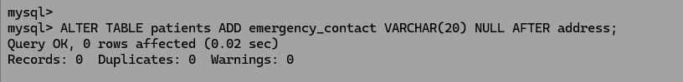

Q12.

ALTER TABLE doctors MODIFY phone VARCHAR(30) NOT NULL;



Q13.

ALTER TABLE appointments ADD CONSTRAINT chk_future_appt_date CHECK (appt_date IS NOT NULL);

Q14.

DROP TABLE prescriptions;
DROP TABLE bills;
DROP TABLE appointments;
DROP TABLE nurses;
DROP TABLE doctors;
DROP TABLE patients;
DROP TABLE wards;
DROP TABLE departments;

Q15.

INSERT INTO departments (dept_name, location, phone_ext, head_doctor) VALUES
-> ('Cardiology', 'Building A, Floor 2', '101', 'Dr. Daham Wijemanna'),
-> ('Pediatrics', 'Building B, Floor 1', '102', 'Dr. Tharush Wijemanna'),
-> ('Neurology', 'Building A, Floor 3', '103', 'Dr. Vishwa Wijemanna'),
-> ('Orthopedics', 'Building C, Ground Floor', '104', 'Dr. Odini Wijemanna');

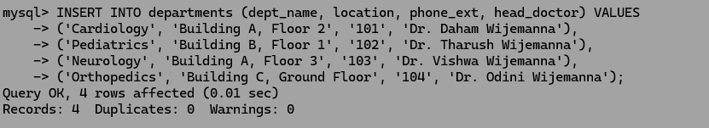

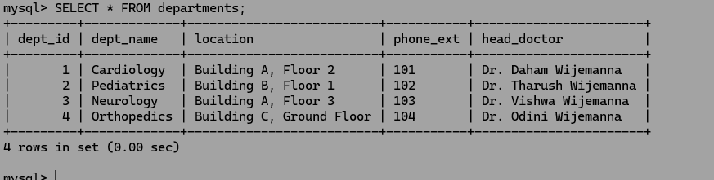

Q16.

INSERT INTO wards (ward_name, capacity, ward_type, dept_id) VALUES
-> ('Cardiology Male Ward', 20, 'General', 1),
-> ('Cardiology ICU', 10, 'ICU', 1),
-> ('Pediatric General Ward', 15, 'Paediatric', 2),
-> ('Pediatric Special Care', 8, 'Paediatric', 2),
-> ('Neurology Male Ward', 25, 'General', 3),
-> ('Neurology Female Ward', 25, 'General', 3),
-> ('Orthopedic Male Ward', 30, 'Surgical', 4),
-> ('Orthopedic Private Unit', 12, 'Surgical', 4);

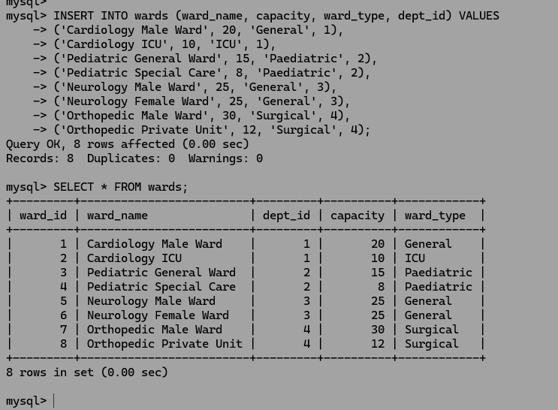

Q17.

INSERT INTO doctors (first_name, last_name, speciality, dept_id, email, phone, hire_date, salary) VALUES
-> ('Daham', 'Wijemanna', 'Cardiologist', 1, 'daham.w@citymed.lk', '0771234567', '2020-01-15', 250000.00),
-> ('Tharush', 'Wijemanna', 'Pediatrician', 2, 'tharush.w@citymed.lk', '0712345678', '2021-03-10', 220000.00),
-> ('Vishwa', 'Wijemanna', 'Neurologist', 3, 'vishwa.w@citymed.lk', '0753456789', '2019-06-01', 280000.00),
-> ('Odini', 'Wijemanna', 'Orthopedic Surgeon', 4, 'odini.w@citymed.lk', '0784567890', '2018-11-20', 300000.00),
-> ('Kaveen', 'Samarawickrama', 'Cardiologist', 1, 'kaveen.s@citymed.lk', '0705678901', '2022-05-12', 210000.00),
-> ('Saween', 'Perera', 'Cardiologist', 1, 'saween.p@citymed.lk', '0705666901', '2022-05-12', 210000.00);

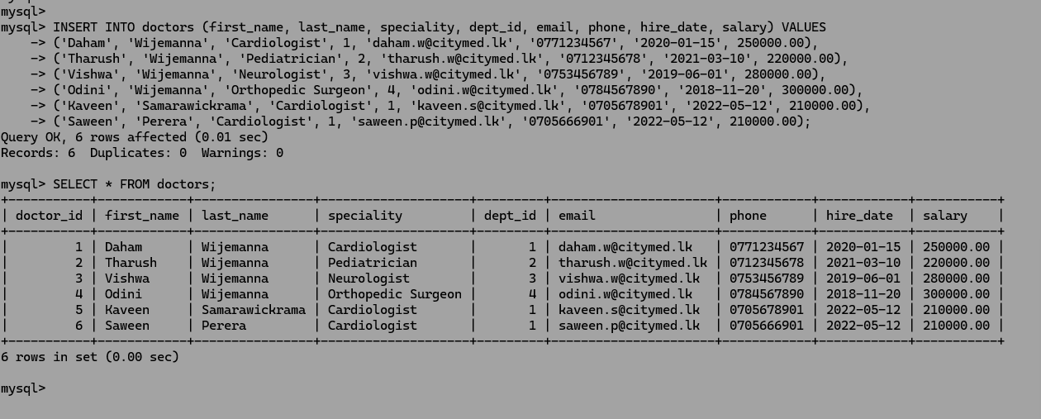

Q18.

INSERT INTO nurses (first_name, last_name, ward_id, shift, email) VALUES
-> ('Samanthi', 'Aarachchige', 1, 'Morning', 'samanthi.aa@citymed.lk'),
-> ('Dilhani', 'Dasanayaka', 2, 'Evening', 'dilhani.da@citymed.lk'),
-> ('Kavinda', 'Thennakoon', 3, 'Night', 'kavinda.th@citymed.lk'),
-> ('Malini', 'Senanayake', 4, 'Morning', 'malini.se@citymed.lk');

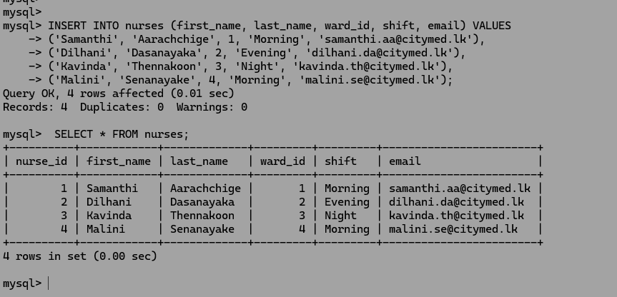

Q19.
INSERT INTO patients (first_name, last_name, dob, gender, blood_group, phone, email, address, emergency_contact) VALUES
-> ('Kamal', 'Gunaratne', '1985-04-12', 'Male', 'A+', '0779876543', 'kamal.g@gmail.com', 'No. 45, Galle Road, Colombo 03', '0771112233'),
-> ('Sunethra', 'Rathnayake', '1992-08-25', 'Female', 'O+', '0718765432', 'sunethra.r@yahoo.com', 'No. 12, Peradeniya Road, Kandy', '0712223344'),
-> ('Mahesh', 'Bandara', '1978-11-03', 'Male', 'B-', '0767654321', 'mahesh@gmail.com', 'Main Street, Kurunegala', '0763334455'),
-> ('Chathurika', 'De Silva', '2000-01-15', 'Female', 'AB+', '0706543210', 'chathuri.d@gmail.com', 'Station Road, Kalutara', '0704445566'),
-> ('Nimal', 'Jayawardena', '1965-06-30', 'Male', 'A-', '0723456789', 'nimal.j@gmail.com', 'Beach Road, Matara', '0725556677'),
-> ('Kavindi', 'Perera', '1997-12-05', 'Female', 'O-', '0789012345', 'kavindi.pe@gmail.com', 'Kandy Road, Gampaha', '0786667788');
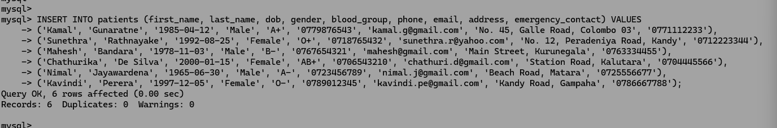
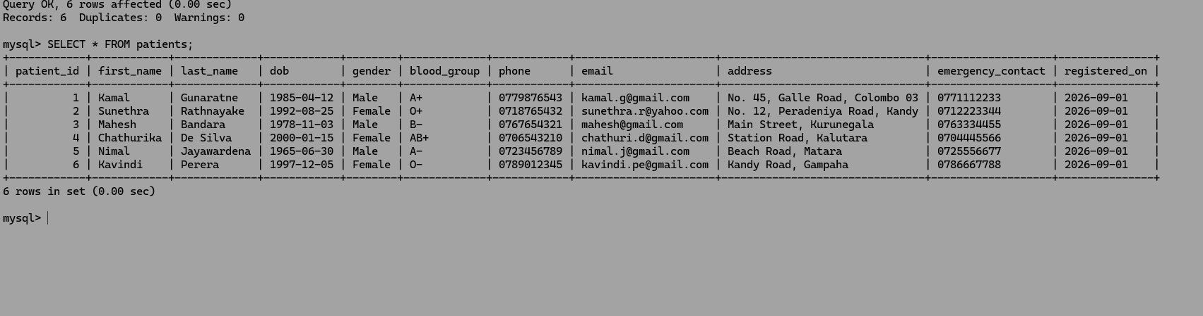

Q20.

INSERT INTO appointments (patient_id, doctor_id, appt_date, appt_time, reason, status, notes) VALUES
-> (1, 1, '2026-09-10', '09:00:00', 'Chest pain checkup', 'Completed', 'Patient has history of high BP'),
-> (2, 2, '2026-09-11', '10:30:00', 'Child fever and cough', 'Completed', 'Routine pediatric checkup'),
-> (3, 3, '2026-09-12', '14:00:00', 'Severe migraine', 'Completed', 'Prescribed pain relief'),
-> (4, 4, '2026-09-13', '11:15:00', 'Knee joint pain', 'Completed', 'X-ray recommended'),
-> (5, 5, '2026-09-14', '08:30:00', 'ECG Follow-up', 'Scheduled', 'Fast for 8 hours before test'),
-> (6, 6, '2026-09-15', '15:00:00', 'Routine Heart Checkup', 'Scheduled', 'First visit'),
-> (1, 2, '2026-09-16', '10:00:00', 'General Checkup', 'Cancelled', 'Patient cancelled due to personal reasons'),
-> (2, 4, '2026-09-17', '16:30:00', 'Joint Pain Follow-up', 'Cancelled', 'Doctor on leave');

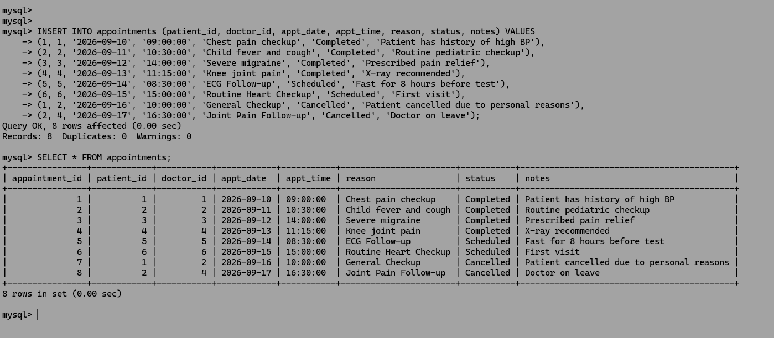

Q21.

INSERT INTO prescriptions (appointment_id, medicine_name, dosage, duration_days, instructions, issued_date) VALUES
-> (1, 'Atorvastatin 10mg', '1 tablet daily at night', 30, 'Take after meals', '2026-09-10'),
-> (1, 'Aspirin 75mg', '1 tablet daily morning', 30, 'Take with food', '2026-09-10'),
-> (2, 'Paracetamol Syrup 120mg/5ml', '5ml every 6 hours', 5, 'For fever only', '2026-09-11'),
-> (3, 'Sumatriptan 50mg', '1 tablet when needed', 10, 'Do not exceed 2 tablets a day', '2026-09-12'),
-> (4, 'Ibuprofen 400mg', '1 tablet twice a day', 7, 'Take after meals', '2026-09-13');

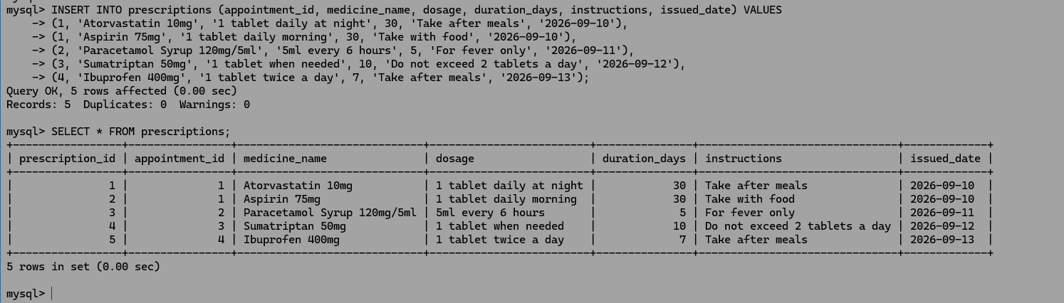

Q22.

INSERT INTO bills (appointment_id, total_amount, paid_amount, payment_status, billing_date) VALUES
-> (1, 5500.00, 5500.00, 'Paid', '2026-09-10'),
-> (2, 3000.00, 1500.00, 'Partial', '2026-09-11'),
-> (3, 4200.00, 0.00, 'Unpaid', '2026-09-12'),
-> (4, 2800.00, 2800.00, 'Paid', '2026-09-13');

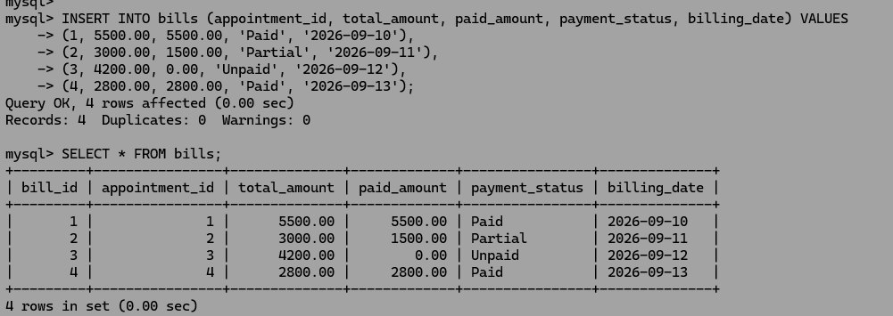

Q23.

UPDATE appointments
-> SET status = 'Cancelled',
-> notes = 'Cancelled by patient due to urgent personal matter'
-> WHERE appointment_id = 5;

Q24.

UPDATE bills
-> SET paid_amount = IF((paid_amount + 5000.00) > total_amount, total_amount, paid_amount + 5000.00),
-> payment_status = IF((paid_amount + 5000.00) >= total_amount, 'Paid', 'Partial')
-> WHERE bill_id = 3;

Q25.

UPDATE doctors d
-> JOIN departments dept ON d.dept_id = dept.dept_id
-> SET d.salary = d.salary * 1.10
-> WHERE dept.dept_name = 'Cardiology';

Q26.

DELETE FROM bills
-> WHERE appointment_id IN(
-> SELECT appointment_id
-> FROM appointments
-> WHERE status = 'Cancelled'
-> );
Q27.

DELETE FROM appointments
-> WHERE status = 'No-Show'
-> AND appt_date < CURRENT_DATE - INTERVAL 2 YEAR;

Q28.

SELECT
-> patient_id,
-> CONCAT(first_name, ' ', last_name) AS full_name,
-> dob,
-> gender,
-> blood_group,
-> phone
-> FROM patients
-> ORDER BY last_name ASC;

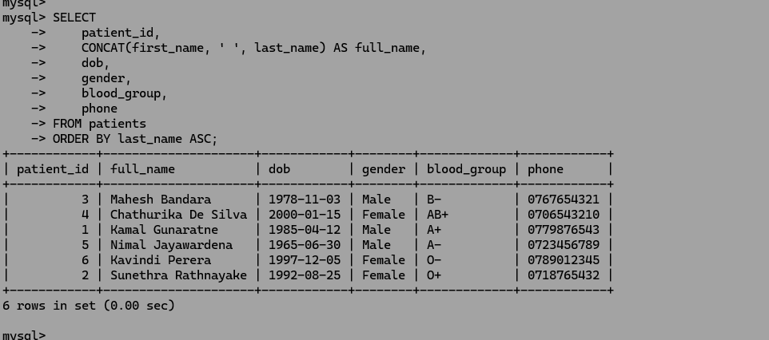

Q29.

SELECT
->CONCAT(p.first_name, ' ', p.last_name) AS patient_name,
->CONCAT(d.first_name, ' ', d.last_name) AS doctor_name,
->a.appt_date,
->a.appt_time,
->a.reason
-> FROM appointments a
-> JOIN patients p ON a.patient_id = p.patient_id
-> JOIN doctors d ON a.doctor_id = d.doctor_id
-> WHERE a.status = 'Scheduled'
-> ORDER BY a.appt_date ASC, a.appt_time ASC;

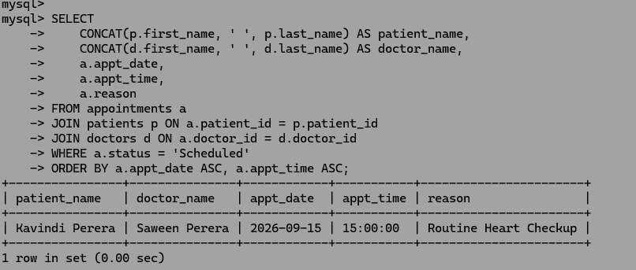

Q30.

SELECT
-> a.appointment_id,
-> CONCAT(p.first_name, ' ', p.last_name) AS patient_name,
-> CONCAT(d.first_name, ' ', d.last_name) AS doctor_name,
-> dept.dept_name,
-> a.appt_date,
-> a.appt_time,
-> a.status
-> FROM appointments a
-> JOIN patients p ON a.patient_id = p.patient_id
-> JOIN doctors d ON a.doctor_id = d.doctor_id
-> JOIN departments dept ON d.dept_id = dept.dept_id;

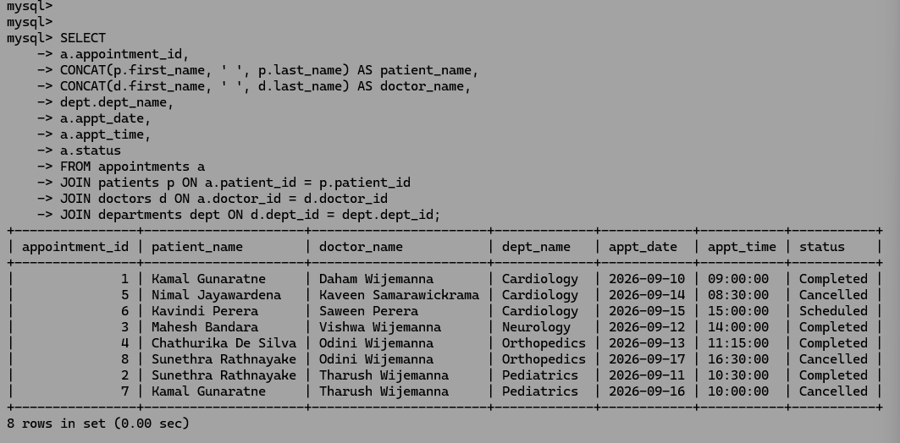

Q31.

SELECT
-> pr.prescription_id,
-> CONCAT(p.first_name, ' ', p.last_name) AS patient_name,
-> CONCAT(d.first_name, ' ', d.last_name) AS doctor_name,
-> pr.medicine_name,
-> pr.dosage,
-> pr.duration_days
-> FROM prescriptions pr
-> JOIN appointments a ON pr.appointment_id = a.appointment_id
-> JOIN patients p ON a.patient_id = p.patient_id
-> JOIN doctors d ON a.doctor_id = d.doctor_id
-> WHERE a.status = 'Completed';

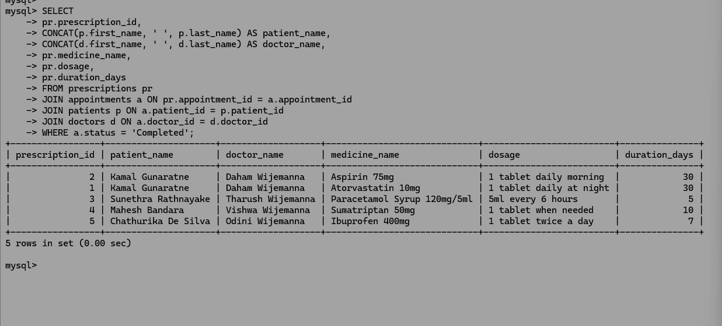

Q32.

SELECT
-> p.patient_id,
-> CONCAT(p.first_name, ' ', p.last_name) AS patient_name,
-> COUNT(a.appointment_id) AS total_appointments
-> FROM patients p
-> LEFT JOIN appointments a ON p.patient_id = a.patient_id
-> GROUP BY p.patient_id, patient_name;

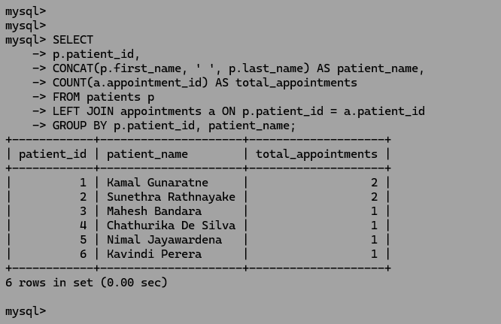

Q33.

SELECT
-> w.ward_id,
-> w.ward_name,
-> COUNT(n.nurse_id) AS nurse_count
-> FROM wards w
-> LEFT JOIN nurses n ON w.ward_id = n.ward_id
-> GROUP BY w.ward_id, w.ward_name;

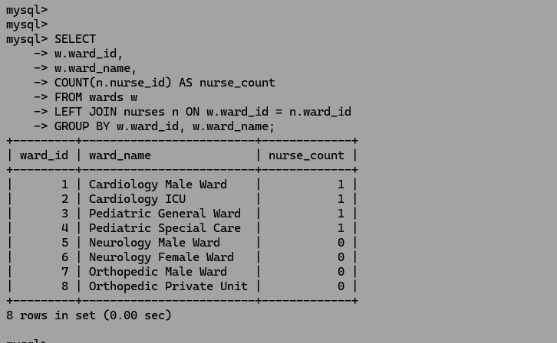

Q34.

SELECT
-> CONCAT(d.first_name, ' ', d.last_name) AS doctor_name,
-> COUNT(a.appointment_id) AS appointment_count
-> FROM appointments a
-> RIGHT JOIN doctors d ON a.doctor_id = d.doctor_id
-> GROUP BY d.doctor_id, doctor_name
-> ORDER BY appointment_count DESC;

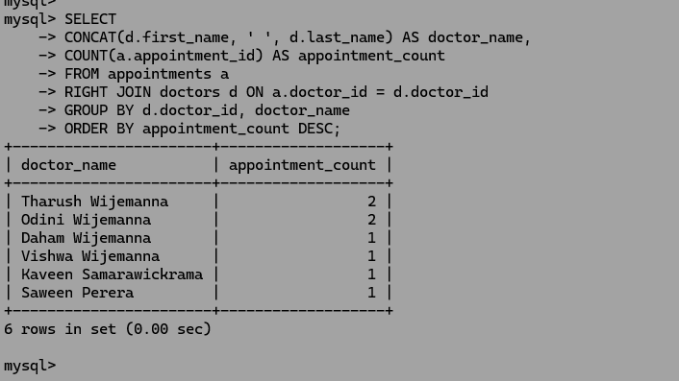

Q35.

SELECT
-> dept.dept_name,
-> COUNT(DISTINCT a.appointment_id) AS total_appointments,
-> COALESCE(SUM(b.total_amount), 0.00) AS gross_revenue,
-> COALESCE(SUM(b.paid_amount), 0.00) AS total_collected_amount,
-> COALESCE(SUM(b.total_amount - b.paid_amount), 0.00) AS outstanding_balance
-> FROM departments dept
-> LEFT JOIN doctors d ON dept.dept_id = d.dept_id
-> LEFT JOIN appointments a ON d.doctor_id = a.doctor_id
-> LEFT JOIN bills b ON a.appointment_id = b.appointment_id
-> GROUP BY dept.dept_id, dept.dept_name
-> ORDER BY gross_revenue DESC;

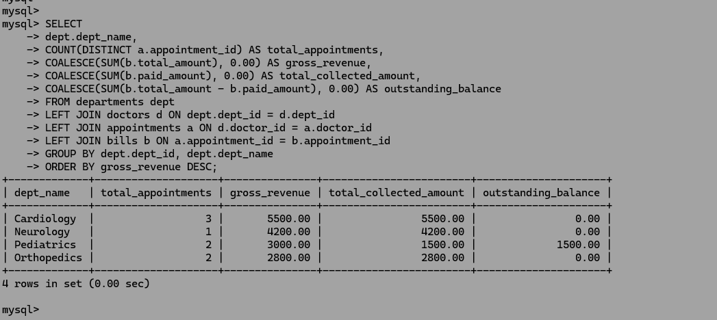

Q36.

SELECT
-> CONCAT(first_name, ' ', last_name) AS patient_name,
-> phone
-> FROM patients
-> WHERE patient_id IN (
-> SELECT a.patient_id
-> FROM appointments a
-> JOIN bills b ON a.appointment_id = b.appointment_id
-> WHERE b.payment_status IN ('Unpaid', 'Partial')
-> );

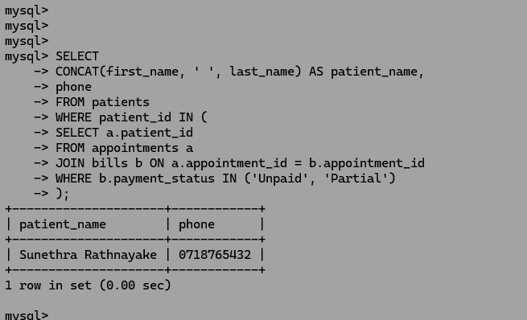

Q37.

SELECT
-> CONCAT(d.first_name, ' ', d.last_name) AS doctor_name,
-> dept.dept_name,
-> d.salary
-> FROM doctors d
-> JOIN departments dept ON d.dept_id = dept.dept_id
-> WHERE d.salary > (
-> SELECT AVG(salary)
-> FROM doctors
-> WHERE dept_id = d.dept_id
-> );

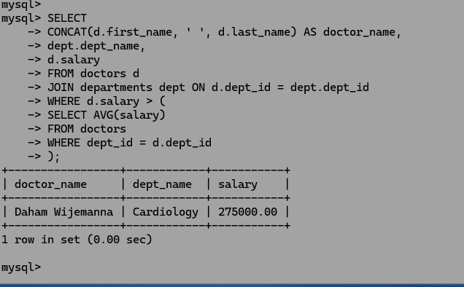

Q38.

departments (dept_id): Uniquely identifies each department in the hospital.

wards (ward_id): Uniquely identifies each ward entity.

doctors (doctor_id): Uniquely identifies each doctor in the system.

nurses (nurse_id): Uniquely identifies each nurse.

patients (patient_id): Uniquely identifies each registered patient.

appointments (appointment_id): Uniquely identifies each appointment booking.

prescriptions (prescription_id): Uniquely identifies each issued prescription.

bills (bill_id): Uniquely identifies each billing invoice.

Q39.

wards -> departments (dept_id)
- ON DELETE / UPDATE: ON DELETE CASCADE ON UPDATE CASCADE
- Reason: Wards logically depend on a department. If a department is deleted or modified, its wards should update/delete accordingly.
doctors -> departments (dept_id)
- ON DELETE / UPDATE: ON DELETE RESTRICT ON UPDATE CASCADE
- Reason: Prevents deleting a department if active doctors are still assigned to it.
nurses -> wards (ward_id)
- ON DELETE / UPDATE: ON DELETE RESTRICT ON UPDATE CASCADE
- Reason: Ensures wards with active nursing staff cannot be deleted accidentally.
appointments -> patients (patient_id)
- ON DELETE / UPDATE: ON DELETE CASCADE ON UPDATE CASCADE
- Reason: Appointments belong to a patient; removing a patient profile should remove their appointment records.
appointments -> doctors (doctor_id)
- ON DELETE / UPDATE: ON DELETE RESTRICT ON UPDATE CASCADE
- Reason: Prevents removing a doctor's history if past/current appointments are attached to them.
prescriptions -> appointments (appointment_id)
- ON DELETE / UPDATE: ON DELETE CASCADE ON UPDATE CASCADE
- Reason: Prescriptions exist only within an appointment context.
bills -> appointments (appointment_id)
- ON DELETE / UPDATE: ON DELETE CASCADE ON UPDATE CASCADE
- Reason: Bills are generated strictly for specific appointments.

Q40.

SELECT
-> CONCAT(p.first_name, ' ', p.last_name) AS patient_name,
-> p.phone,
-> b.total_amount
-> FROM patients p
-> JOIN appointments a ON p.patient_id = a.patient_id
-> JOIN bills b ON a.appointment_id = b.appointment_id
-> ORDER BY b.total_amount DESC
-> LIMIT 1;

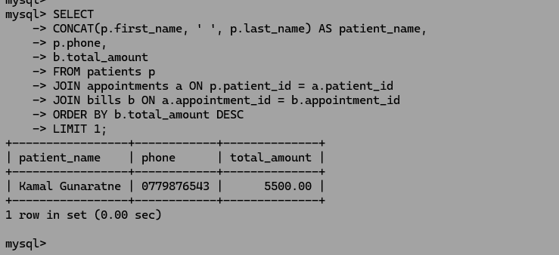

Q41

departments.dept_name: Prevents duplicate department names.
doctors.email: Ensures each doctor has a unique email.
nurses.email: Ensures each nurse has a unique email.
bills.appointment_id: Enforces a strict 1:1 relationship between an appointment and its bill.
prescriptions(appointment_id, medicine_name): Enforces the business rule that a single medicine cannot be prescribed multiple times within the same appointment.

Q42.

SELECT dept_id, dept_name
-> FROM departments
-> WHERE dept_id NOT IN (
-> SELECT DISTINCT dept_id
-> FROM wards
-> WHERE dept_id IS NOT NULL
-> );

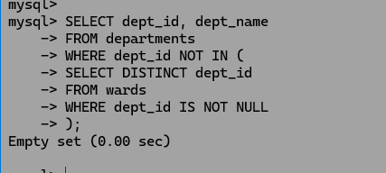

Q43.

SELECT
-> CONCAT(d.first_name, ' ', d.last_name) AS doctor_name,
-> a.status AS appointment_status,
-> COUNT(a.appointment_id) AS total_appointments
-> FROM doctors d
-> LEFT JOIN appointments a ON d.doctor_id = a.doctor_id
-> GROUP BY d.doctor_id, doctor_name, a.status
-> ORDER BY doctor_name ASC;

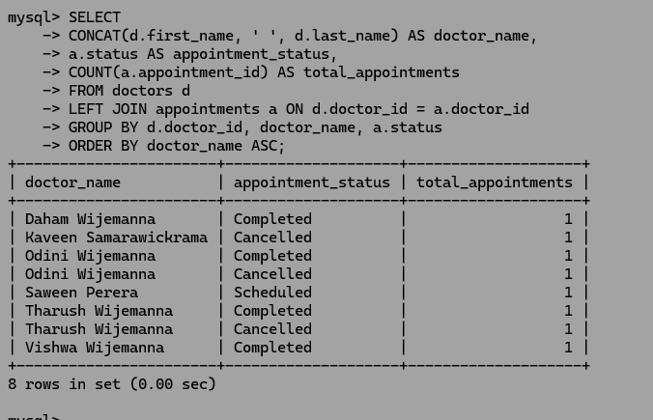

Q44.

wards.capacity (capacity BETWEEN 1 AND 100):
Enforces realistic ward sizes and prevents negative or zero capacity.

doctors.salary (salary > 0):
Prevents invalid negative or zero salary amounts.

prescriptions.duration_days (duration_days BETWEEN 1 AND 365):
Prevents invalid prescription durations.

bills.total_amount (total_amount > 0):
Ensures bill amounts are strictly positive.

bills.paid_amount (paid_amount <= total_amount):
Prevents overpayment entries where paid amount exceeds the total bill.

Q45.

SELECT
-> CONCAT(p.first_name, ' ', p.last_name) AS patient_name,
-> COUNT(DISTINCT d.dept_id) AS different_departments_visited
-> FROM patients p
-> JOIN appointments a ON p.patient_id = a.patient_id
-> JOIN doctors d ON a.doctor_id = d.doctor_id
-> GROUP BY p.patient_id, patient_name
-> HAVING COUNT(DISTINCT d.dept_id) > 1;
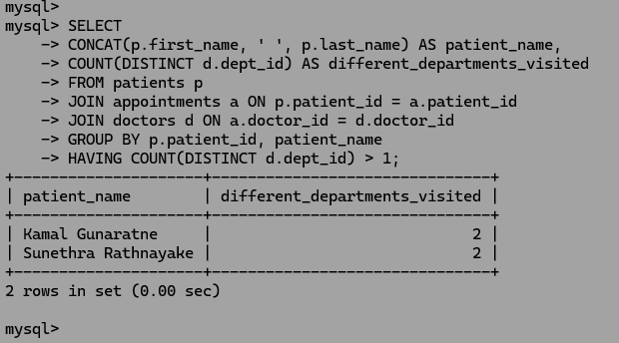
Q46.

ALTER TABLE prescriptions ADD CONSTRAINT chk_max_duration CHECK (duration_days <= 365);

Q47.

Current Behavior:

Since ON DELETE RESTRICT is set, attempting to delete a department that has doctors assigned to it will cause MySQL to return an error and prevent the deletion.

Justification / Alternative:

In a real-world scenario, if a department closes down, doctors may need to be transferred to another department or temporarily marked as unassigned. Therefore, using ON DELETE SET NULL (and making dept_id nullable) is more appropriate.

Q48.

ALTER TABLE bills ADD CONSTRAINT chk_billing_date_valid CHECK (billing_date IS NOT NULL);

Q49.

PRIMARY KEY:
Uniquely identifies each record in a database table. It cannot contain NULL values (NOT NULL), and a table can have only one Primary Key.
- Example: patient_id in the patients table.

UNIQUE Constraint:
Prevents duplicate values in a column. However, it allows NULL values (depending on the database engine). A table can have multiple Unique constraints.
- Example: email in the doctors table.

Q50.

- Referential Integrity:
Refers to maintaining the accuracy and consistency of data across Foreign Key relationships in a relational database. It ensures that a value cannot be added to a child table if it does not exist in the parent table.

  - Example: The patient_id Foreign Key in the appointments table links to the patient_id in the patients table. By preventing the creation of an appointment for an unregistered patient, the system preserves data referential integrity.

